**System Deliverable 0**

**System Overview and Team Members**

System Overview

1. The name of the System is *The Force*
2. *The Force* is a schedule-generating program. Any student using the program will be given the option to generate schedules for their remaining semesters in Concordia University’s Software Engineering program. The schedules generated will be based on a number of criteria and constraints of which the student will be given control over. Some of these constraints would include options like “Try and get a day off”, or “No classes after 6pm”.

One function the System will provide the user would be the ability to add/remove courses and schedule constraints. The ability to switch between semesters and view course sequences, course availabilities, course descriptions (including detail such as teachers, room numbers, etc…), and course pre-requisites will also be provided for the user.

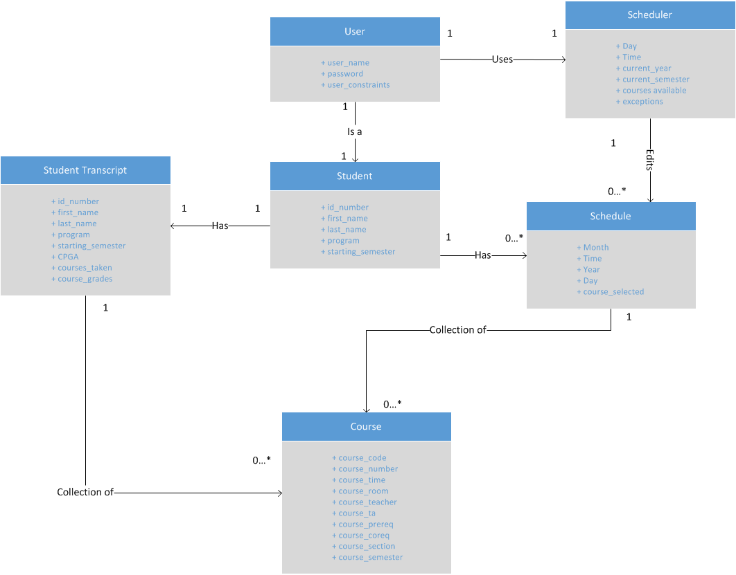

User

* The ‘User’ class is an entity representing a user of the system. This class contains 3 attributes. They are user_name, password and user_constraints. The username and password are used for logging into the website. The user_constraints are limitations entered by the user such as number of days off, time free and courses to avoid.
* The ‘User’ class is related to one ‘Student’ class to represent that each user is a registered student at Concordia University in the 174
* The ‘User’ class is also related to one ‘Scheduler’ class to represent that each user will use the scheduler tool to create schedules in the system.

Scheduler

* The ‘Scheduler’ class is an entity representing the key concept of the system, the schedule creation. The class contains 6 attributes; Day, Time, current_year, current_semester, courses_available and exceptions. Day, Time, current_year and current_semester and variables that will be filled when a student add/drops a class in their schedule. Courses_available are courses that will be given in a certain semester. Exceptions will be created on the user_constraints entered by the user.
* The ‘Scheduler’ class is related to 0 or more ‘Schedule’ objects to represent that the scheduler can create one or more schedules for various semesters and years

Schedule

* The ‘Schedule’ class is an entity representing the schedule made by a user for a certain semester/year. The class contains 5 attributes. They are Month, Time, Year, Day and course_selected (All self-explanatory).
* The ‘Schedule’ class is a subset of the scheduler is related to 0 or more ‘Courses’ to represent that a ‘Schedule’ is a collection of courses made by a ‘Student’.

Student

* The ‘Student’ class is a specialized case of the user. The class contains 5 attributes; id_number, first_name, last_name, program, starting_semester. (All self-explanatory).
* Each 'Student' in the system is associated one 'Student Transcript'. This is the student’s academic history. Also, each ‘Student’ is related with 0 or more ‘Schedule’ which represent the user’s schedules for any academic year.

Student Transcript

* The ‘Student Transcript’ class is an entity representing courses that the ‘Student’ has already taken. This also shows other information about the ‘Student’.
* Each ‘Student Transcript’ is related to 0 ore more ‘Courses’ to represent the classes that a ‘Student has already taken’.

Course

* The ‘Course’ class is an entity detailing all the information about courses available to software engineering students during various years/semesters.

Team Members

1. The name of the team is the *Code Jedi*.

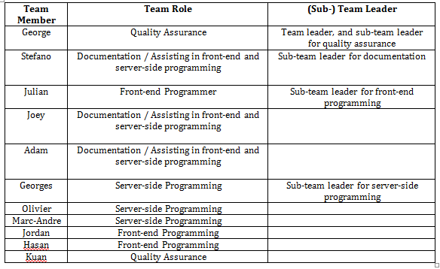

1. The team leader for the entire System is George Theophanous.

GitHub: <https://github.com/wolfcall/SOEN341>